CONFIGURAÇÃO REDE ANTERIOR

**Configure the ISAKMP Phase 1 properties on R1**

Protocolo ISAKMP de negociação

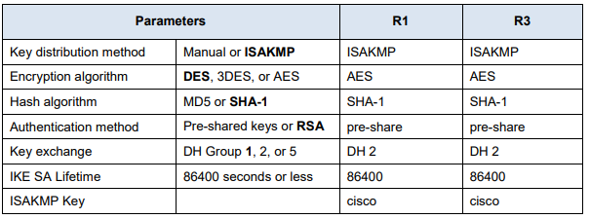

crypto isakmp policy 10

authentication pre-share

hash sha

encryption aes 256

group 2

lifetime 86400

exit

crypto isakmp key toor address 10.1.1.2

**Configure the ISAKMP Phase 2 properties on R1**

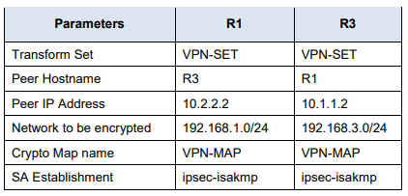

crypto ipsec transform-set TSET esp-aes esp-sha-hmac

access-list 101 permit ip 192.168.1.0 0.0.0.255 192.168.2.0 0.0.0.255

crypto map CMAP 10 ipsec-isakmp

set peer 10.0.0.2

match address 101

set transform-set TSET

exit

**Configure the crypto map on the outgoing interface**

interface fa0/0

crypto map CMAP

do wr

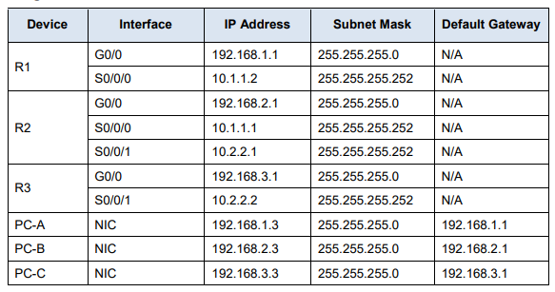

CONFIGURAÇÃO REDE ROUTER 1

access-list 110 permit ip 192.168.1.0 0.0.0.255 192.168.3.0 0.0.0.255

crypto isakmp policy 10

authentication pre-share

hash sha

encryption aes 256

group 2

lifetime 86400

exit

crypto isakmp key toor address 10.2.2.2

crypto ipsec transform-set VPN-SET esp-3des esp-sha-hmac

crypto map VPN-MAP 10 ipsec-isakmp

description VPN connection to R3

set peer 10.2.2.2

set transform-set VPN-SET

match address 110

exit

interface fa0/1

crypto map VPN-MAP

do wr

CONFIGURAÇÃO REDE ROUTER 3

access-list 110 permit ip 192.168.3.0 0.0.0.255 192.168.1.0 0.0.0.255

crypto isakmp policy 10

authentication pre-share

hash sha

encryption aes 256

group 2

lifetime 86400

exit

crypto isakmp key toor address 10.1.1.2 (outro router)

crypto ipsec transform-set VPN-SET esp-3des esp-sha-hmac

crypto map VPN-MAP 10 ipsec-isakmp

description VPN connection to R3

set peer 10.1.1.2

set transform-set VPN-SET

match address 110

exit

interface fa0/1

crypto map VPN-MAP

do wr

COMANDOS PARA VERIFICAR

show crypto isakmp sa

show crypto ipsec as